AEROTHON 23

TEAM ALTITUDE

COEP Technological University

Email Id: arsc@coeptech.ac.in

Contact:

LinkedIn Profile: https://www.linkedin.com/company/aerial-robotics-study-circle/mycompany/

TEAM MEMBERS:

Saikishore Naidu

Vijaysingh Rajput

Soham Kumthekar

Prathviraj Chavan

Shivam Mishra

Anushka Shalu

Kalyani Vidhate

Krushal Mahajan

Bhushan Sonawane

Ishan Kulkarni

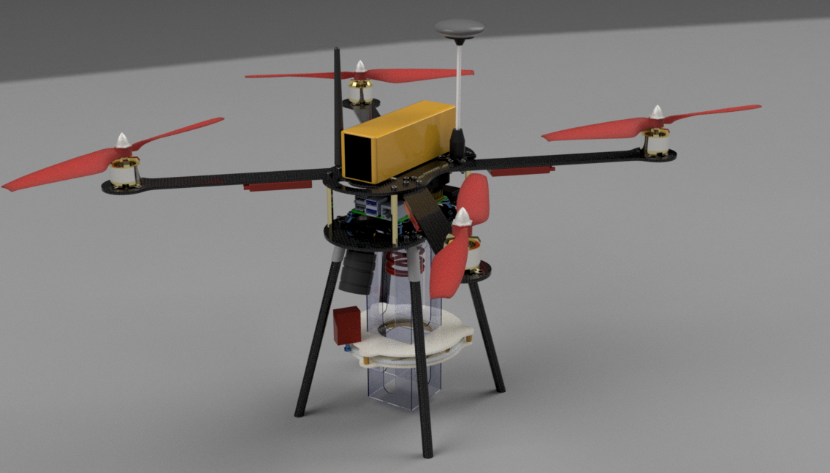

**INDEX**

|  |  |  |  |
| --- | --- | --- | --- |
| **SR.NO** | | **TITLE** | **PAGE NO** |
| **1** | | **Conceptual Design** | **4** |
| **2** |  | **Detailed Design** |  |
|  | **2.1** | Preliminary weight estimation | **4** |
|  | **2.2** | Estimation of Thrust required | **4** |
|  | **2.3** | Propulsion System | **5** |
|  | **2.4** | UAV Sizing | **8** |
|  | **2.5** | UAV Performance | **9** |
|  | **2.6** | Material Selection | **11** |
|  | **2.7** | Subsystem Selection | **14** |
|  | **2.8** | Payload dropping mechanism | **22** |
|  | **2.9** | Preliminary CAD mode | **23** |
| **2.10** | | Computational Analysis   * *Kinematic analysis using MATLAB.* * *Static stress analysis of Frame using ANSYS.* * *Velocity streamline analysis of propeller.* | **24** |
|
|
|  | **2.11** | Optimized final design | **27** |
|  | **2.12** | Detailed weight breakdown | **28** |
|  | **2.13** | UAV Performance recalculations | **28** |
|  | **2.14** | CG of final Design | **29** |
| **3** | | **Final specs and bill of materials** | **30** |
| **4** | | **Methodology for Autonomous operations** | **31** |
| **5** | | **Summary of innovations in design** | **34** |
|  |  | **appendix A** | **35** |

**1.Conceptual Design:**

We have chosen quadcopter with X- configuration.

The motors to be mounted to the rotor arms which will be connected to the central hub.

The central hub consists of a upper plate and a lower plate which also acts as the power distribution board.

The battery will be kept in between the two plates and the flight controller and microcontroller will be mounted on top of the upper plate. This plate will also act as the support for the housing unit.

The payload dropping and camera mechanism will be attached to the bottom plate. The legs also will be suspended from here.

**2. Detailed Design:**

**2.1. Preliminary weight estimation:**

|  |  |
| --- | --- |
| Frame | 250gm |
| Electronic components | 600gm |
| Battery | 500gm |
| Payload Mechanism | 350gm |
| **Total** | 1700 gm (Appx.) |

**2.2. Estimation of Thrust required:**

Considering the 2:1 ratio of thrust to take-off weight, we need an approximate thrust

=2 x take-off weight

=2 x 2kg

=4kg.

Thus, thrust required by each motor=

= (total thrust/no. of motors) +20%

So, each motor needs to give 1.2kg of thrust. The thrust force=1.2 x 9.81=11.772N, this is approximately 1.2kgf of thrust force.

**2.3. Propulsion System:**

We are using electric propulsion system with DYS D2836-7 1120KV Outrunner Brushless Drone Motor and double blade propellers.

Fig: Motor

Fig: Propellers

**Motor Mounting :**

Large flange and vertically upside motor mounting

**The reasons for selection OF DYS D2836-7 1120KV Outrunner Brushless Drone Motor:**

1. The net weight of our quadcopter is 2kg. To get optimum thrust from motor we selected this motor which gives 1130g thrust when applying 3s LiPo battery.

The required thrust estimation is given in section 2.2.

1. This motor gives 1120 rpm per volt.
2. We will be using a 3S Lipo battery with these motors.
3. Each cell gives 3.7volt so net voltage obtained by the 3 pack of cells is11.1 Volt. So, each motor gets voltage according to required rpm and thrust requirement.

**TECHNICAL SPECIFICATION OF BLDC MOTOR:**

|  |  |
| --- | --- |
| Parameter | Value |
| Brand name | DYS |
| Model | D2836-7 |
| Operating voltage | 7.4-14.8 V |
| KV rating | 1120 |
| Max. power | 336W |
| Recommended ESC | 40A |
| Weight | 70gm (including connectors) |
| Shaft dimensions | Ф4.0*49mm |
| Screw size | M3 |
| Max Current | 18A |
| No load current | 1A |

**Motor dimensions:**

Fig: Orthographic views of motor

**No. of blades**

1. The main talking points here are thrust and efficiency.

2. Also, 2-blade propellers are

a. easy to carry.

b. durable in case of collisions due to their flexibility

3. They also have a low price.

4. Highly responsive to changes made to the RPM.

5. A 3 blade will create higher amount of thrust and stability but is heavier and slower in operation along with increased battery consumption.

6. A 2-blade propeller is more likely to rotate out of the way in case the drone goes down, whereas a 3-blade propeller is prone to damage in any kind of crash.

7. However, the double blade propeller provides enough thrust, and its work efficiency is optimum along with its other salient features and advantages, as per the required design.

**Specification:**

1. Material: Carbon Nylon

2. Size: 10 × 4.5''

3. Weight: 26g per pair

4.Shaft diameter: 9.64mm

5. Hole size: 3.87mm

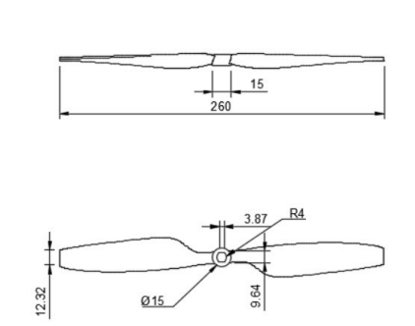

**2.4. UAV Sizing:**

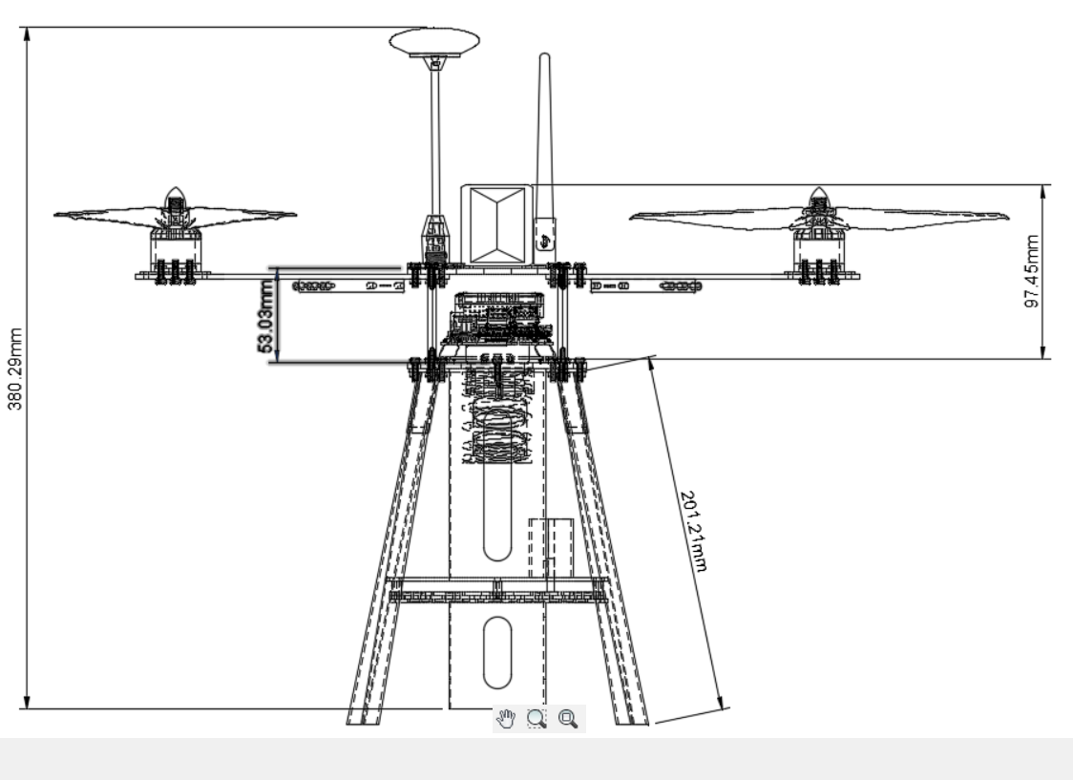

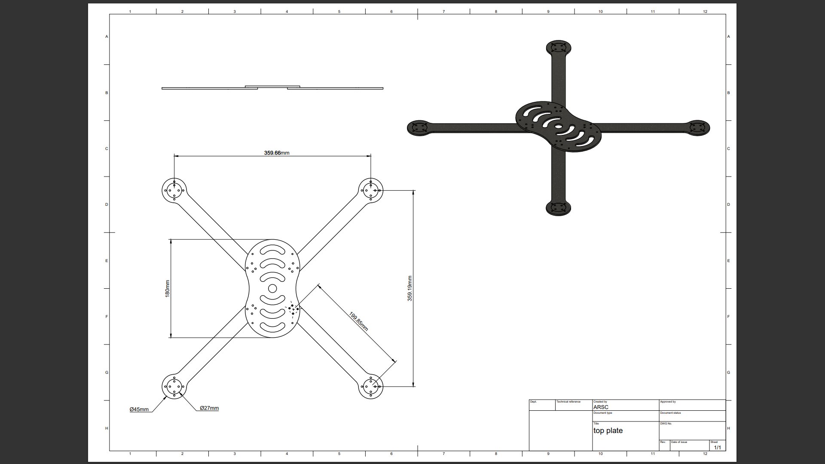*(HUB, LANDING GEAR, TOTAL HEIGHT)*

*(More orthographic views are in appendix section)*

**2.5. UAV Performance**

The time provided for completing the flight is 10mins. This is the major influencer for battery selection and power requirements. The selected battery should provide us with the required power.

**Battery:**

A. Choosing:

1. Compared to Li-po, LI-ion has more specific energy, but it is more Volatile, vulnerable to damage from high temperatures, heavier, loses its capacity to charge, and may burst if the separator is destroyed.

2. Ni-MH battery was discovered to have a low Power to weight ratio and a cell voltage of just 1.2 V when compared to Li-Po battery.

3. As a result, we chose lithium polymer batteries.

B. Calculations:

1. In Li-po batteries each cell has 3.7volts. Thus, a 3S battery will have 3x3.7=11.1V.

This is within the operating range for our motors.

1. For longer flight time, the capacity should be good.

Fig: battery

C. Other Specifications of Li-Po:

|  |  |
| --- | --- |
| Model No. | ORANGE 6200/3S-40C |
| Capacity (mAh) | 6200 |
| Weight (gm) | 446 |
| Output Voltage (VDC) | 11.1 |
| Charge Rate (C) | 1 ~ 3 |
| Discharge Plug | HXT 4mm |
| Balance Plug | JST-XH |
| Length (mm) | 155 |
| Width (mm) | 50 |
| Height (mm) | 25 |
| Max. Burst Discharge (C) | 50C (310A) |
| Max. Charge Rate | 5 C |
| Max. Continuous Discharge | 40C (248A) |

**Flight time estimation:**

The approximate flight time can be calculated as: battery current capacity x 60 (min).

Current drawn

As the maximum portion of current drawn is due to the motors, we can neglect the other components for preliminary flight time estimation.

The maximum current drawn by motor is 18A i.e., for the maximum thrust of 1130gm, 18A current is drawn. And for hovering the drone we need a safe 600 gm of thrust from each motor. So, the average current drawn can be estimated to 7-8A per motor.

Hence, average current drawn by all motors will be 8x4=32A

So, the estimated time of flight will be (6.2/32) x60= 11.625 min.

This value is not entirely accurate, but we have considered upper limit of the average current range to get a better estimate.

**2.6. Material Selection:**

Materials which had revolutionized the aeronautical industry in past few years including alclad sheets, carbon fibre composite, titanium alloys. For the drone frames we need the material which must have properties like it should be lightweight, stiffer tough durable, strong enough with high tensile strength. According to the requirement, we studied several materials for the drone frame including,

**2.6.1 Carbon Fibre Reinforced Polymer (CFRP)**

a) Reasons for selecting CFRP

i) CFRP is extremely strong and light fibre-reinforced

plastics that contain carbon fibres.

ii) It has high strength to weight ratio of (approx) 2457 kN.m/kg

iii) Carbon fibre is corrosion resistant and chemically stable

iv) It has low coefficient of thermal expansion

b) Properties of CFRP

i) Tensile strength (approx.) = 6 to 7 GPa

ii) Strength to weight ratio (approx.) = 2457 kN.m/kg

iii) Poisson-ratio (approx.) = 0.26-0.28

CFRP possesses excellent resistance to corrosion, fatigue, and impact, ensuring the drone frame can withstand harsh environmental conditions and potential collisions.

The durability of CFRP extends the lifespan of drones and reduces maintenance requirements, resulting in cost savings for operators.

We are using it for arms, landing gear, and top plate and bottom plate.

For landing gear, we have used 3ktwill rod of carbon fibre.

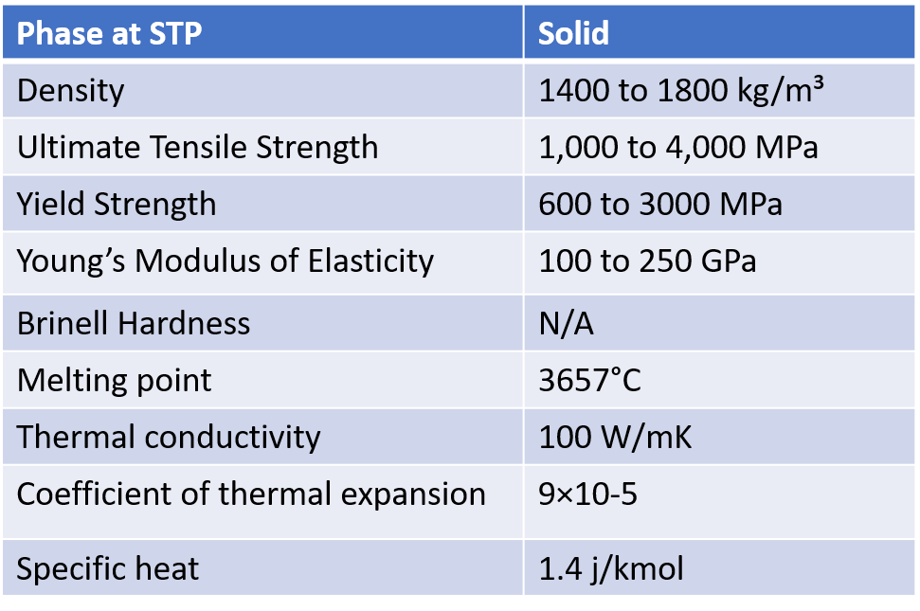

Table: Properties of CFRP

**2.6.2) ABS (Acrylonitrile Butadiene Styrene)**

Advantages of ABS

ABS can be easily molded and shaped, allowing for intricate designs and complex geometries. ABS is a tough material with good impact resistance.It can withstand heavy loads and is less likely to break or shatter when subjected to sudden impacts or stresses.

Ductility and Flexibility:

ABS is known for its ductility and flexibility, allowing it to absorb and distribute forces during impact. This property helps prevent fractures and increases the overall durability of the drone parts.

Why do we use ABS?

Ease of Processing: ABS is a thermoplastic material that can be easily molded and formed into complex shapes using techniques like injection molding or 3D printing.

This makes it convenient for manufacturing drone parts with intricate designs or custom geometries.

ABS is a thermoplastic that can be easily molded, or 3D printed, providing flexibility in design and allowing for complex shapes or custom components.

This is particularly useful in drone manufacturing, where optimizing aerodynamics, structural integrity, and component integration is essential. We are using ABS for landing gear mounts.

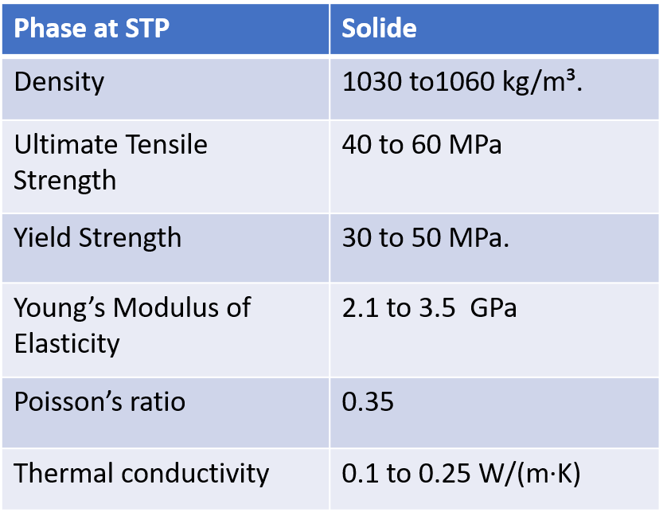

Table: Properties of ABS

**2.6.3 Glass fibre reinforced plastic (GFRP)**

Advantages of GFRP

It is lighter than steel but possesses comparable or even superior strength, making it an attractive choice for applications where weight reduction is crucial.

GFRP is an excellent electrical insulator.

WHY WE USE GFRP MATERIAL

GFRP is used for its high strength-to-weight ratio.

Manufacturing process: Resin Mixing: The epoxy resin is prepared by mixing the epoxy base resin with a hardener or curing agent.

GFRP's inherent toughness and impact resistance help protect the internal components and ensure the drone's ability to withstand minor accidents or rough landings.

GFRP's electrical insulation properties help prevent interference and short circuits, ensuring reliable and safe operation of the drone's electrical system.

We are using GFRP for coating the ABS mounts and the arms and hub joining area.

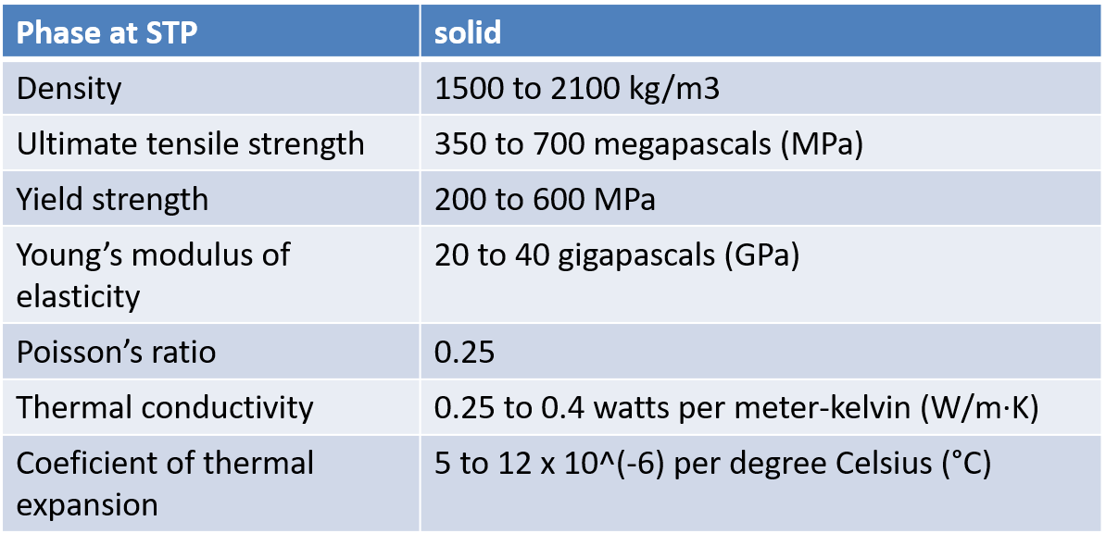

Table: Properties of GFRP

**2.6.4 Acrylic sheets:**

We are using 2mm sheets of acrylic material.

**Advantages:**

* Acrylic sheets can be easily molded, extruded, or thermoformed into various shapes and sizes.
* sheets are excellent electrical insulators.
* 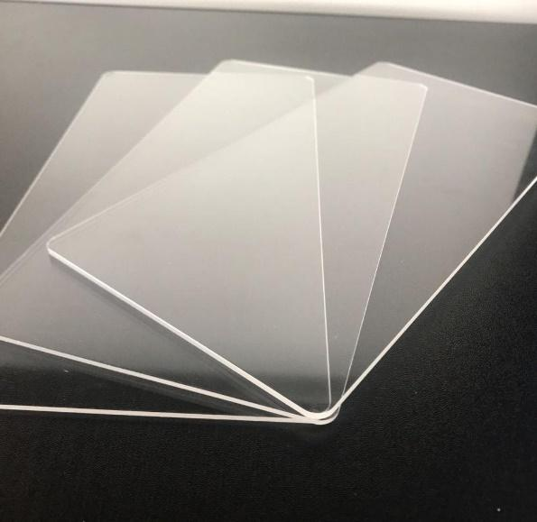Thermal stability: Acrylic sheets exhibit good dimensional stability over a wide range of temperatures.
* Impact resistance: Acrylic sheets are more impact-resistant than glass, making them a safer option in certain applications.

**Other properties:**

* Density= 1170 to 1200 g/cm³
* Ultimate Tensile strength= 60 to 80 MPa
* Thermal conductivity= 0.19-0.20 W/(mK)

We are using acrylic for the payload dropping mechanism.

**Conclusion:**

By leveraging the specific properties of each material, drone manufacturers can optimize performance, weight, and durability to meet their requirements and deliver reliable and efficient drones. The choice of material depends on factors such as budget, desired performance, weight limitations, and specific application needs.

**2.7. Subsystem Selection:**

**Communication subsystem**

Drones are the best way to carry out any small-scale aerial jobs, we see them everywhere, be it photography domain, food delivery, defence, agriculture and you name it! Due to its versatility, it can be put to work as its size is optimal for carrying out the work it has been assigned with. It is potentially the future of aerial business as it will also help in minimizing human efforts in hazardous circumstances. 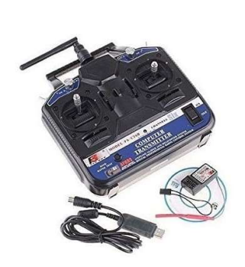

These Drones are controlled by ‘Transmitters’. A Drone Radio Transmitter is a wireless electronic device that makes use of radio signals to transmit instructions using a set radio frequency over to the receiver, which is connected to the drone being controlled from a distance.

Control Modes: The transmitter offers four control modes that allow the user to choose the control stick configuration that suits them best. The control modes are mode 1 (throttle right), mode 2 (throttle left), mode 3 (throttle right but with the control sticks switched), and mode 4 (throttle left but with the control sticks switched).

Transmitter performance: The FS-CT6B transmitter operates at 2.4 GHz, which is less prone to interference than lower frequency radio systems. The transmitter has an output power of less than 100 mW, which means that it can be used legally without a license in most countries.

LCD Display: The transmitter has a clear and easy-to-read LCD display that displays important information such as battery voltage, signal strength, trim settings, and channel status.

Channels: The FS-CT6B transmitter offers 6 control channels that can be used to control various functions on the RC plane, such as throttle, elevator, ailerons, rudder, and auxiliary functions.

Receiver Compatibility: The transmitter is compatible with a wide range of receivers, including the FS-R6B receiver. The receiver can be easily connected to the transmitter using a simple bonding process.

Battery life: The transmitter can be powered by 8xAA batteries or a rechargeable battery (not included). The transmitter also has a built-in charging port that can be used to charge the rechargeable battery.

Range: The transmitter has a range of up to 1000 meters, making it suitable for a wide range of RC applications.

Modes: The transmitter offers a variety of modes, including trainer mode, throttle, and servo reverse.

Ergonomics: The transmitter is ergonomically designed, with a comfortable grip and intuitive button placement. This makes it easier to use for a longer period of time.

Overall, the FS-CT6B transmitter is a versatile and reliable radio control system that offers a range of features and functions. Its easy-to-use interface, compatibility with a variety of receivers, and long-range applications.

**SPECIFICATIONS OF THE SELECTED DRONE RADIO TRANSMITTER**

* Channels: 6 CH
* Control Distance: Up to 1000 meters in the air
* Super active and passive anti-jamming capabilities.
* Very low power consumption.
* High receiving sensitivity.
* 8 model memory, digital control.
* We can program by PC with the included software.
* 4 Types (Airplane, Heli90, Heli120, Heli140).
* Use a linear spread of fine paragraph by an excess antenna.
* It covers the entire bandwidth of the antenna bandwidth range.
* High quality and stability.

1. Operating Voltage: 12 V

2. Weight: 511 gm

3. Dimension: 189x97x295 mm

**Navigation Subsystem:**

The M8N GPS is a high-precision Global Navigation Satellite System (GNSS) receiver module that is widely used in various applications such as drones, autonomous vehicles, and navigation systems. Here is a detailed description of the M8N GPS module:

GNSS system: The M8N GPS module is compatible with the Global Navigation System (GPS) and the Russian Global Navigation Satellite System (GLONASS). This means it can receive signals from both GPS and GLONASS satellites to provide more accurate and reliable location information.

Chipset: The M8N GPS module uses the u-blox M8N chipset, which is a high-performance GNSS receiver that provides accurate location information even in challenging environments such as urban canyons and forested areas.

Positioning Accuracy: The M8N GPS module has a positioning accuracy of up to 2.5 meters, making it ideal for applications that require highly accurate position data.

Refresh rate: The M8N GPS module has a fast refresh rate of up to 10 Hz, which means it can provide up to 10 updates of position, speed and time data per second.

Antenna: The M8N GPS module comes with a built-in ceramic patch antenna that provides good signal reception and eliminates the need for an external antenna.

Interfaces: The M8N GPS module has a number of interfaces, including UART, I2C and USB. This makes it easy to interface with a variety of devices such as microcontrollers, single board computers and other devices.

Power consumption: The M8N GPS module has a low power consumption of only 45mA, making it ideal for battery-powered applications.

Operating Temperature Range: The M8N GPS module has an operating temperature range of -40°C to 85°C, making it suitable for use in a wide range of environments and applications.

Size: The M8N GPS module has a compact size of 25mm x 25mm x 4mm, which makes it easy to integrate into various devices.

**Camera Module:**

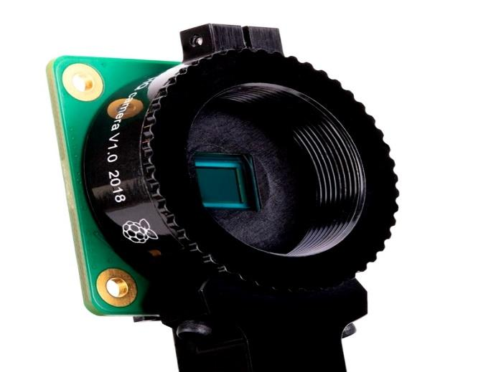**Raspberry Pi High Quality Camera**

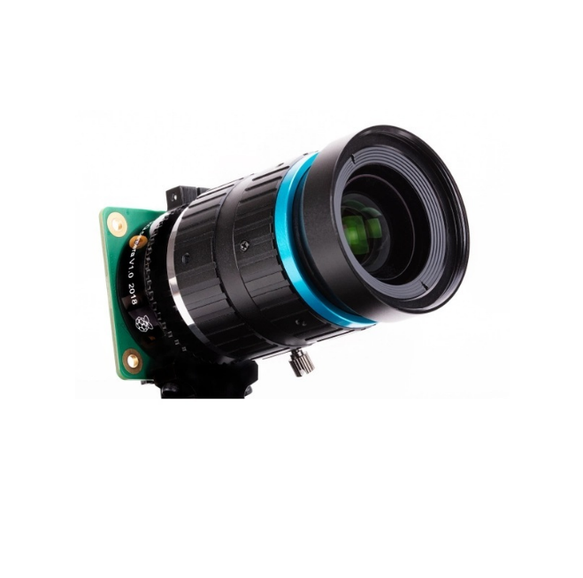Fig: Camera

1.Sensor: The High-Quality Camera features a 12.3-megapixel Sony IMX477 sensor. This larger sensor size allows for improved image quality and the ability to capture more detail in photos and videos.

2.Lens Compatibility: The High-Quality Camera has a C-mount lens mount, which allows for the attachment of various interchangeable lenses. This provides flexibility in choosing different lenses and adjusting focus, iris, and other lens settings.

3.Image Quality: With its higher resolution sensor, the High-Quality Camera is capable of capturing detailed images with reduced noise. It also offers better low-light performance compared to the standard camera module.

4.Video Recording: The High-Quality Camera supports video recording at resolutions up to 1080p at 30 frames per second. It also supports hardware-accelerated video encoding, which helps reduce the load on the Raspberry Pi processor.

5.Accessories: To fully utilize the High-Quality Camera, we may need additional accessories such as a C-mount lens, lens adapter. These accessories can enhance our photography capabilities and provide more options for creative applications.

6.Connection: The Raspberry Pi Camera Module is a camera designed specifically for use with Raspberry Pi boards. It connects to the Raspberry Pi via a ribbon cable and interfaces with the camera interface (CSI) connector on the Raspberry Pi board.

7.Configuration: We will need to enable the camera interface on the Raspberry Pi. Open the Raspberry Pi Configuration Tool by entering the command in the terminal.

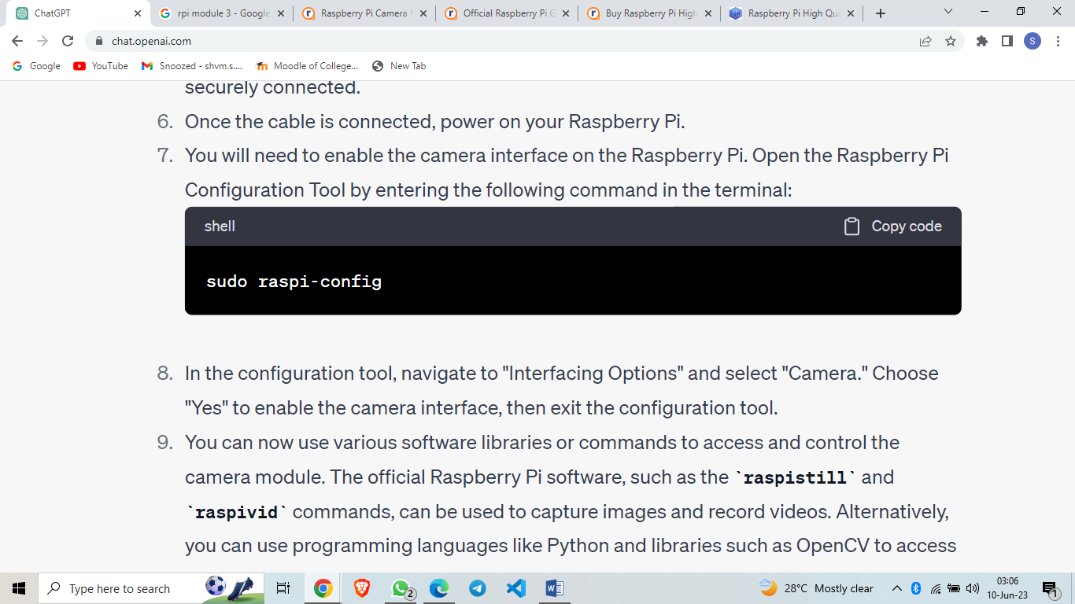

In the configuration tool, navigate to “Interfacing Options” and select “Camera.” Choose “Yes” to enable the camera interface, then exit the configuration tool.

8.Programmability: We can now use various software libraries or commands to access and control the camera module. The official Raspberry Pi software, such as the raspistill and raspivid commands, can be used to capture images and record videos. Alternatively, you can use programming languages like Python and libraries such as OpenCV to access and process the camera data.

**Transmitter-Receiver:**

**Boscam 32Ch Wireless AV Transmitter TS832 Receiver RC832**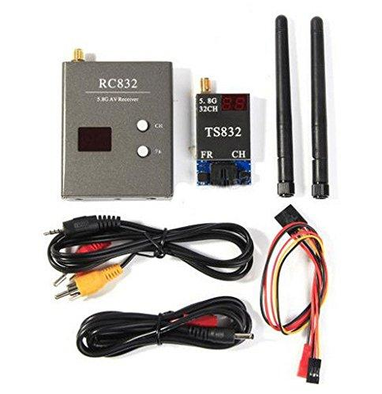

Boscam TS832 wireless AV transmitter and RC832 receiver are commonly used components for wireless audio and video transmission in FPV (First Person View) applications, such as drone racing or remote monitoring.

Boscam TS832 Wireless AV Transmitter:

•Channels: The TS832 transmitter supports 32 selectable channels, allowing us to choose the desired frequency for transmission.

•Transmission Power: It has adjustable transmission power levels, typically ranging from 200mW to 600mW, providing flexibility in different environments and ranges.

•Input/Output: The transmitter accepts audio and video signals from a compatible source, typically through RCA or AV cables. It also features an SMA antenna connector for attaching an external antenna.

•Compatibility: The TS832 transmitter is commonly used with FPV cameras or other video sources to wirelessly transmit the video feed to a receiver.

Boscam RC832 Receiver:

•Channels: The RC832 receiver is designed to receive the wireless audio and video signals transmitted by the TS832 transmitter. It also supports 32 selectable channels, allowing you to match the frequency with the transmitter.

•Antenna: The receiver comes with an SMA antenna connector for attaching an external antenna to improve reception.

•Output: The RC832 receiver provides audio and video output through RCA or AV cables, allowing you to connect it to a display or recording device.

* Connection:

Connect Receiver Antenna to the mobile device using USB cable.

**Flight Controller: Pixhawk**

Pixhawk, being a versatile flight control system for unmanned aerial vehicles (UAVs), supports integration with a variety of sensors to gather data about the aircraft’s environment and its own state. Here are some commonly used sensors that can be connected to a Pixhawk system:

1. 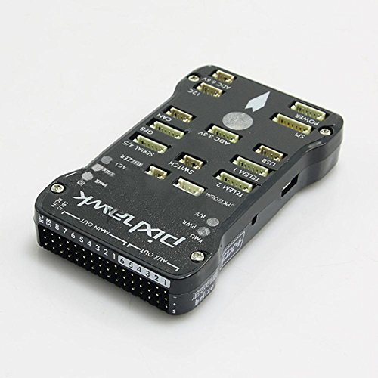Inertial Measurement Unit (IMU): The IMU consists of accelerometers, gyroscopes, and magnetometers. It provides information about the UAV’s attitude (roll, pitch, and yaw), acceleration, and orientation in three-dimensional space.
2. Global Positioning System (GPS): GPS receivers provide accurate positioning and navigation data, including latitude, longitude, altitude, and velocity. They are crucial for autonomous flight, waypoint navigation, and precise positioning.
3. Barometer: Barometric pressure sensors measure atmospheric pressure changes to estimate the UAV’s altitude. They are used for altitude hold, vertical speed control, and altitude-related calculations.
4. Compass: Compass sensors, such as magnetometers, detect the Earth’s magnetic field and help determine the UAV’s heading. They are essential for accurate orientation and navigation.
5. Proximity Sensors: Proximity sensors, such as ultrasonic or LiDAR sensors, detect nearby obstacles and enable obstacle avoidance capabilities. They are commonly used in autonomous drones to maintain safe distances from objects during flight.
6. Airspeed Sensor: Airspeed sensors measure the relative airspeed of the UAV, providing crucial data for stabilizing flight, controlling airspeed, and compensating for wind conditions.
7. Voltage and Current Sensors: These sensors monitor the battery voltage and current consumption of the UAV, allowing for real-time battery status monitoring, estimation of remaining flight time, and voltage-based failsafe features.
8. Optical Flow Sensors: Optical flow sensors track the ground movement beneath the UAV, enabling precise position hold, altitude control, and stabilization in environments with limited GPS availability, such as indoors or close to the ground.
9. Telemetry Radio: While not a sensor itself, a telemetry radio module is used to establish a wireless communication link between the Pixhawk and a ground control station, enabling real-time data transmission and remote control of the UAV.

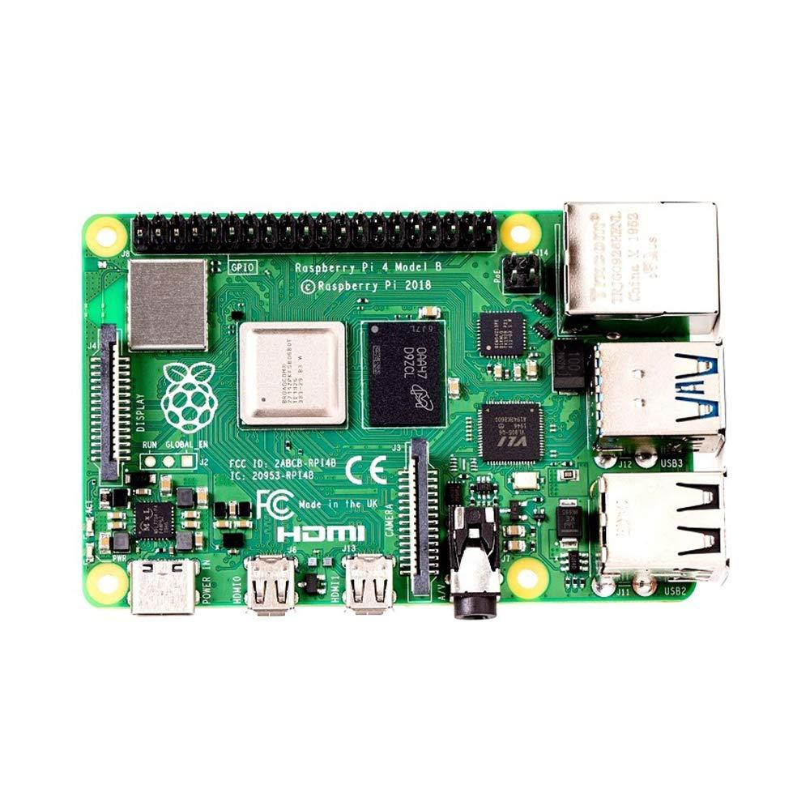**Raspberry Pi:**

The Raspberry Pi 4 Model has various ports and connections that allow for versatile connectivity. Here are the main ports and connections available on the Raspberry Pi 4:

1. HDMI Ports: The Raspberry Pi 4 has two micro-HDMI ports (HDMI 2.0) that support up to 4K resolution. These ports are used to connect the Raspberry Pi to displays or TVs.
2. USB Ports: There are two USB 2.0 ports and two USB 3.0 ports on the Raspberry Pi 4. These ports are used to connect various USB devices such as keyboards, mice, external storage drives, cameras, and other peripherals.
3. Ethernet Port: The Raspberry Pi 4 has a Gigabit Ethernet port, allowing for fast and reliable wired network connectivity.
4. USB-C Power Port: The Raspberry Pi 4 uses a USB-C power connector for power supply. It is recommended to use a power supply specifically designed for the Raspberry Pi 4 to ensure stable and sufficient power delivery.
5. GPIO Pins: The Raspberry Pi 4 features a 40-pin GPIO (General Purpose Input/Output) header, which provides access to a wide range of programmable I/O pins. These pins can be used to interface with sensors, actuators, and other electronics components.
6. MicroSD Card Slot: The Raspberry Pi 4 uses a microSD card for its operating system and storage. The microSD card slot is where you insert the microSD card with the Raspberry Pi’s operating system installed.
7. Camera and Display Interfaces: The Raspberry Pi 4 has a MIPI CSI camera interface for connecting a Raspberry Pi camera module and a MIPI DSI display interface for connecting compatible displays.
8. Audio/Video Jack: The Raspberry Pi 4 has a 3.5mm audio/video jack that supports stereo audio output and composite video output. This jack can be used to connect speakers, headphones, or composite video displays.
9. Wireless Connectivity: The Raspberry Pi 4 has built-in wireless connectivity options. It supports dual-band 2.4GHz and 5GHz Wi-Fi (802.11b/g/n/ac) and Bluetooth 5.0.

Other electronic components and subsystems are given below:

|  |  |
| --- | --- |
| **Component** | **Specifications** |
| Power distribution board | ∙ Dimensions:180 x 118 x 2mm   * Weight:50 gm |
| Electronic Speed Controllers | ReadytoSky 40A 2-4S ESC for Drone   * BEC output: 5V 3A. * Weight (gm) 30 * Burst Current 60A. * Constant Current 40A. * Dimensions 7 x 3mm2. |
| Servo Motor | TowerPro MG90S Mini Digital Servo Motor (180° Rotation)   * Weight: 13 gm * Operating voltage: 4.8V~ 6.6V * Dimensions: 12.4 x 22.8 x 32.5 mm3. |

**Pixhawk Connections:**

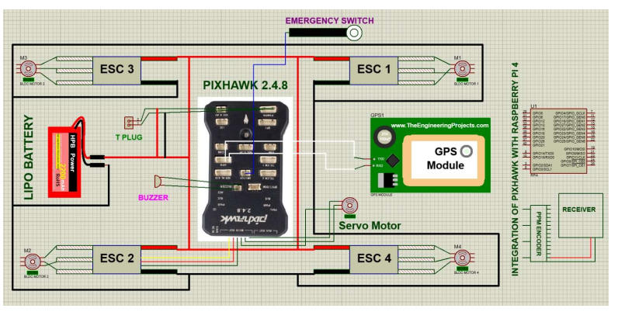

**2.8. Payload dropping mechanism:**

Our innovative payload dropping mechanism draws inspiration from the natural mechanisms found in the human eye pupil and camera iris. It utilizes acrylic sheets to construct a cuboidal-shaped structure that houses the mechanism. The iris, made of acrylic sheet, is controlled by a servo motor, allowing it to open and close with precision.

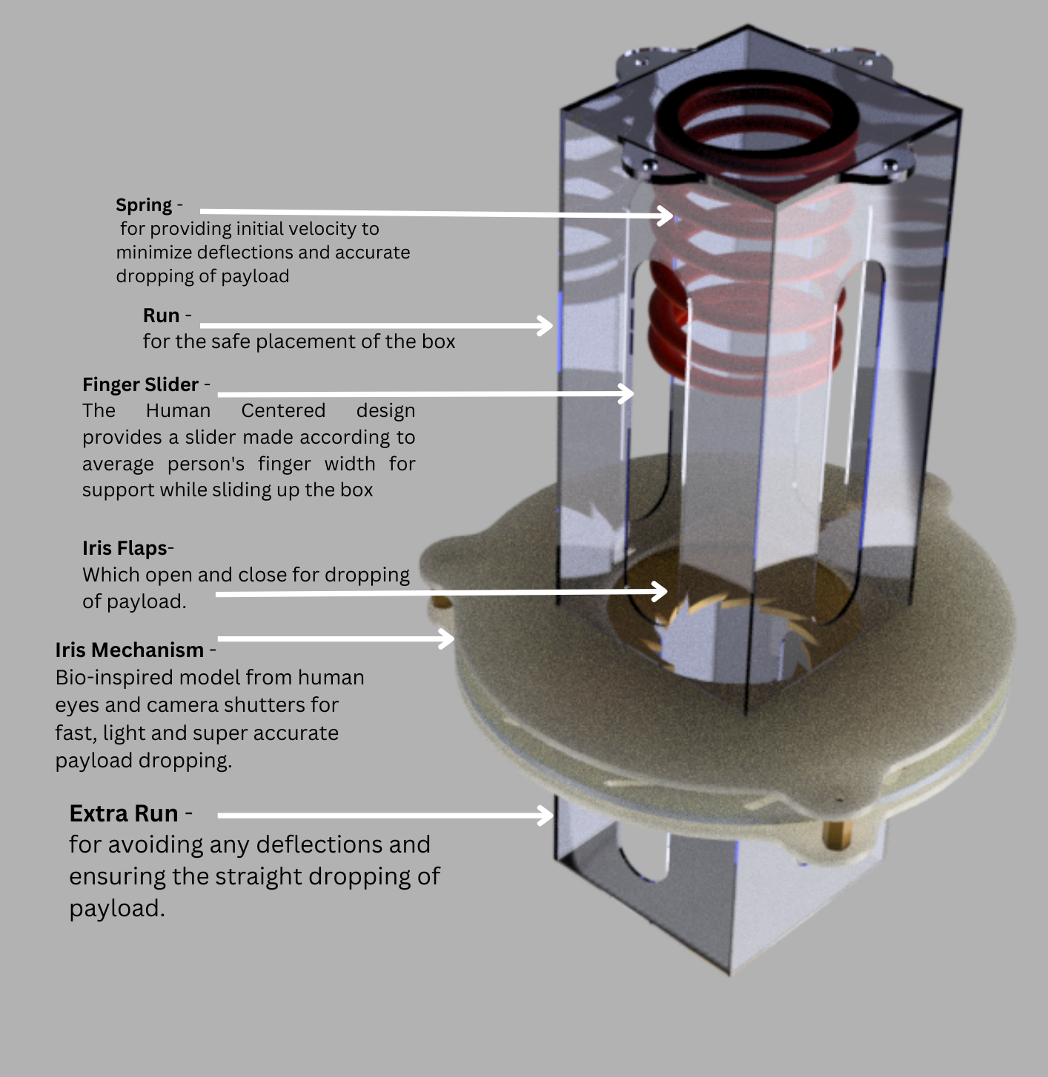

The mechanism consists of an interior space specifically designed to accommodate the payload. At the top of the mechanism, a spring is incorporated into the structure, serving to firmly secure the payload between the iris and the roof of the mechanism. When the iris opens, triggered by the servo motor, the spring force propels the payload along a downward trajectory.

The design we made is very human centred the slots in the side you see are made according to an average person’s finger width so, that he can easily slide the payload box upwards. In addition, the screws are given on the outside so, as to have a novel approach to convenient design for assembly. We have also incorporated a longer run for the payload mechanism in order for it to adjust it for any deflection and ensure the straight dropping of payload.

Our payload system is engineered to be light, accurate and human centred. The efficient dropping of payload is ensured by first imparting velocity by the spring. It has a longer run for adjusting from deflections and also takes it far enough to be affected form the drones our air flow.

1. b)

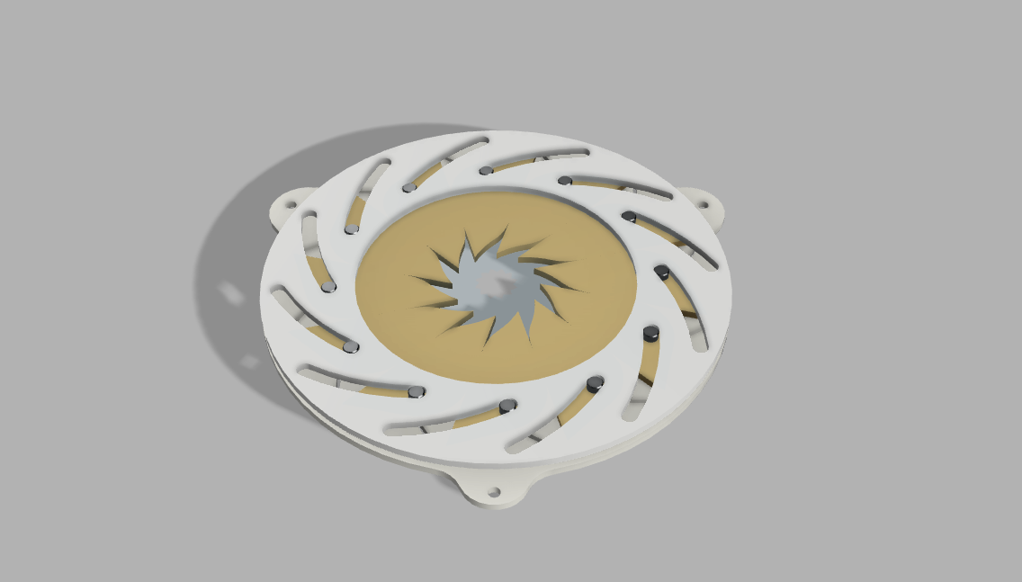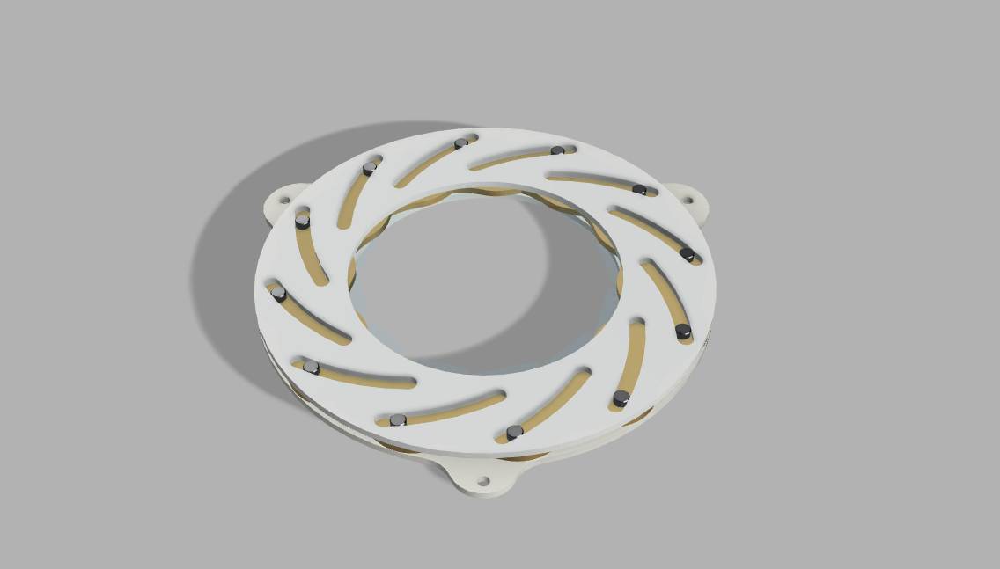

(*Iris positions: a) open b) close)*

The mechanisms well built walls guide the descending cargo, ensuring a controlled descent. Our payload dropping mechanism provides a dependable and precise payload release mechanism for our drone by using the concepts of the iris mechanism.

**2.9. Preliminary CAD model:**

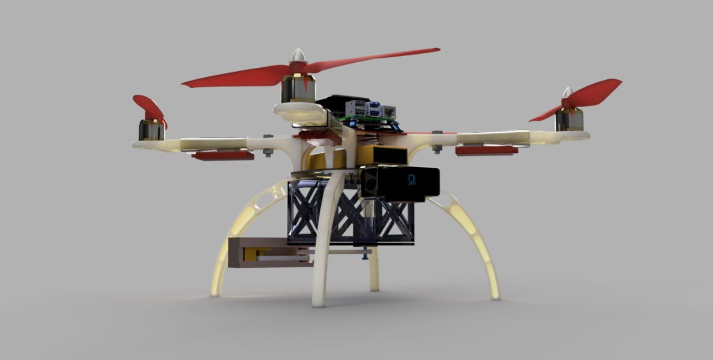

The 450 frame, landing gear of 17 cm , and payload mechanism of slider crank two flap opening mechanism combined with the ABS frame covered in GFRP results in a strong and adaptable drone design. It offers the requisite stability, functionality, and payload deployment capabilities.

**2.10. Computational Analysis:**

**2.10.1Kinematic analysis using MATLAB:**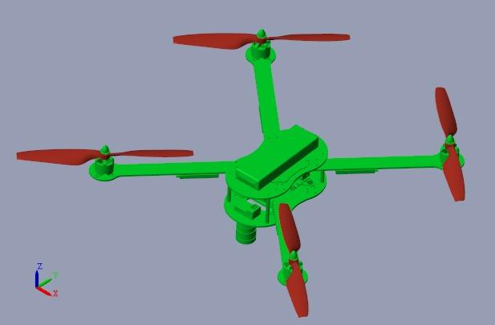

We have used MATLAB / Simulink model to analyse our drone’s motion. We imported our CAD model and studied its behaviour by giving rotation to the propellers, thus analysing the stability. We observed the effect of direction of propeller rotation on the quadcopter body.

We also used simscape to visualize the simulation:

We have given velocities as input and calculated the displacement of drone and its behavioural path.

Fig: Simscape model

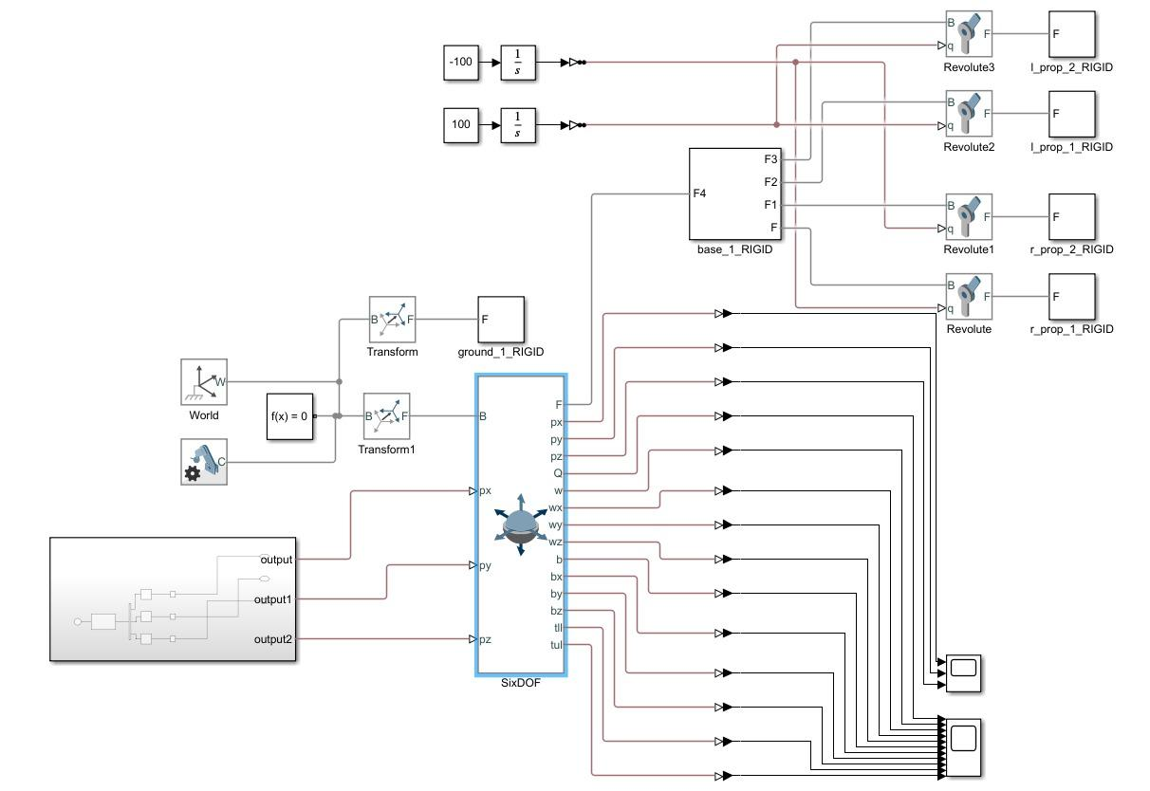

Fig: Simulink model

We have used the 6DOF block in Simulink to give the body 3-dimensional motion. We have connected an output signal generator to feed velocities as an input the 6DOF block. The velocities are with respect to the base(B) i.e., the ground. The output of the 6DOF block consists of follower(F) which is connected to the quadcopter. We also get the input velocities in the output along with position(Q), Angular velocities(w), Angular accelerations(b) and torque. The results were recorded in scope block. A screenshot of a graph

Fig: Velocity graph (In X, Y and Z direction respectively) in scope 1

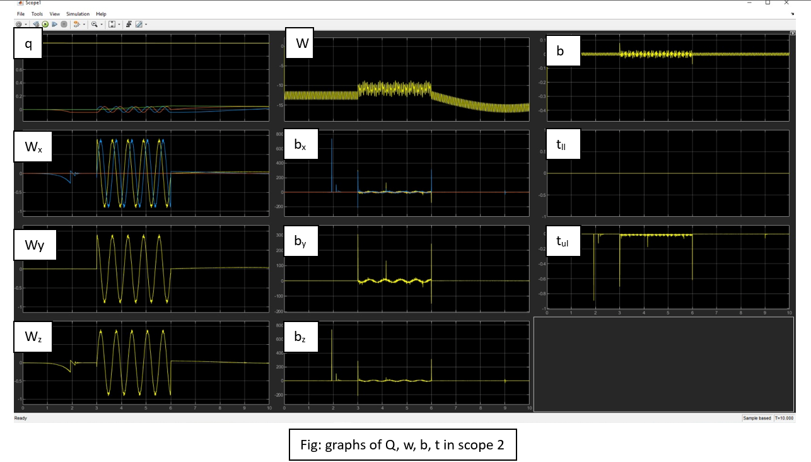

**2.10.2 Static stress analysis of Frame using ANSYS**

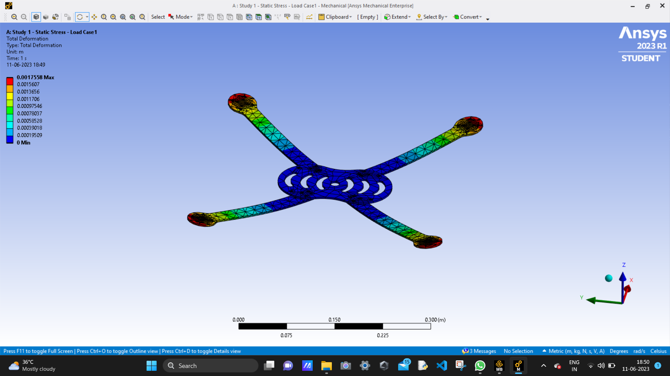We assessed the deformation of our drone frame using an ANSYS static stress analysis. The highest deformation measured varied from 1 mm to 1.7 mm, according to the data. This study gives important information on the structural integrity of our drone frame, guaranteeing that it can handle the imposed stresses and operate reliably in a variety of settings.

**2.10.3 Velocity streamline analysis of propeller on Ansys**

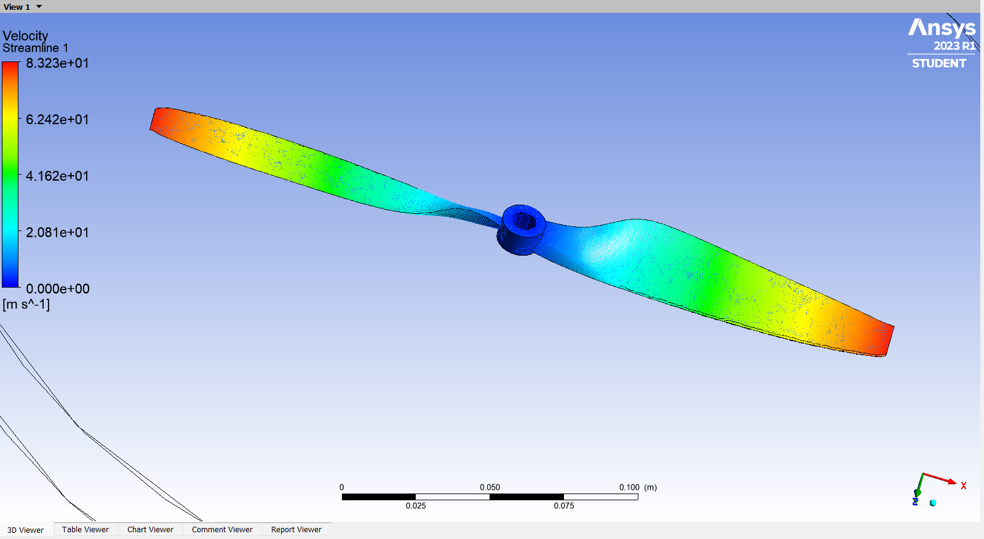

**2.11. Optimized final design:**

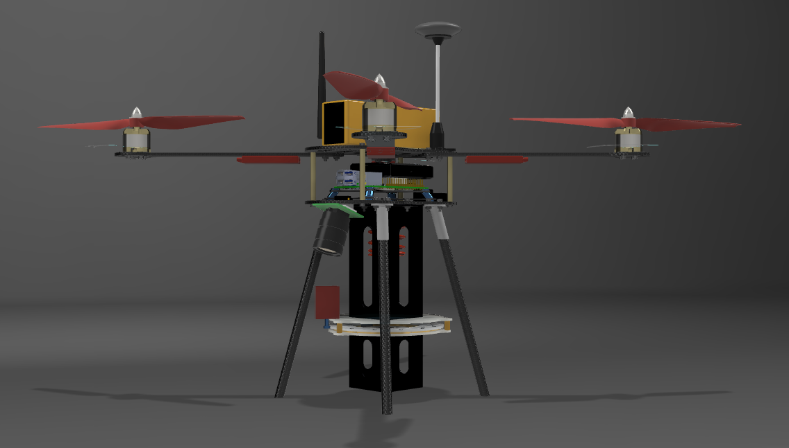

Our drone is built with a lightweight carbon fibre frame and an X-shaped quadcopter layout. To provide lift for steady flight, the propulsion system features 1045 propellers on the motors. The payload mechanism is screwed firmly to the bottom of the base plate, allowing for quick payload deployment. A camera is also attached at the bottom to record a large coverage area. The landing gear is comprised of carbon fibre rods with rubber studs at the bottom, which provides strong support and ensures safe landings. This complete design combines strength, agility, and functionality, making it suitable for a wide range of applications.

* 1. **Detailed weight breakdown**

|  |  |  |  |
| --- | --- | --- | --- |
| Component | Weight | Quantity | Net Weight(gms) |
| Drone Frame |
| Arms | 28 | 4 | 112 |
| Base Plate | 90 | 1 | 90 |
| Legs | 12 | 4 | 48 |
| Propeller | 13 | 4 | 52 |
| Electronic Components |
| Motor | 70 | 4 | 280 |
| Pixhawk | 40 | 1 | 40 |
| Raspberry Pi | 45 | 1 | 45 |
| Camera | 53 | 1 | 53 |
| ESC | 35 | 4 | 140 |
| GPS | 26 | 1 | 26 |
| VTX | 25 | 1 | 25 |
| Receiver | 25 | 1 | 25 |
| Battery | 446 | 1 | 446 |
| Payload Mechanism |
| Frame | 140 | 1 | 140 |
| Servo Motor | 13 | 1 | 13 |
| Spring | 15 | 1 | 15 |
| Buffer (wires and fasteners) |  |  | 150 |
| **TOTAL** |  |  | **1700 gms** |

* 1. **UAV Performance recalculations:**

**Power Required for the mission:**

Power consumed by Motors:

The selected motor has a maximum current draw of 18A. The battery is providing voltage of 11.1 V. Therefore, the maximum power that the motor can consume is:

Power = Voltage x Current Power = 11.1V x 18 A Power = 200 W

Max Power consumed by 4 Motors = 4 X 200 = 800 W

The Pixhawk 2.4.8 is a flight controller board that requires a 5V power supply with a maximum current draw of 2.5A. Therefore, the maximum power consumption of the Pixhawk 2.4.8 would be:

Power = Voltage x Current Power = 5V x 2.5A Power = 12.5W

Power consumed by raspberry pi ranges from 3.5-4 W and of camera is 2 W.

Along with this, assumed some losses of 5 W.

Total maximum power required (Approx…) = 800+12.5+2+5W = 819.5 W

**Endurance estimation:**

The motor can draw a maximum of 18A, or for a maximum thrust of 1130gm, 18A current. Additionally, each engine must produce a safe 600 grammes of force for the drone to hover. Therefore, it is possible to assume that each motor draws 7-8A on average.

Consequently, the total average current drawn by all motors will be 8x4=32A.

Therefore, the calculated flight time will be (6.2/32) x 60 = 11.625 minutes.

**2.14 CG of final design**

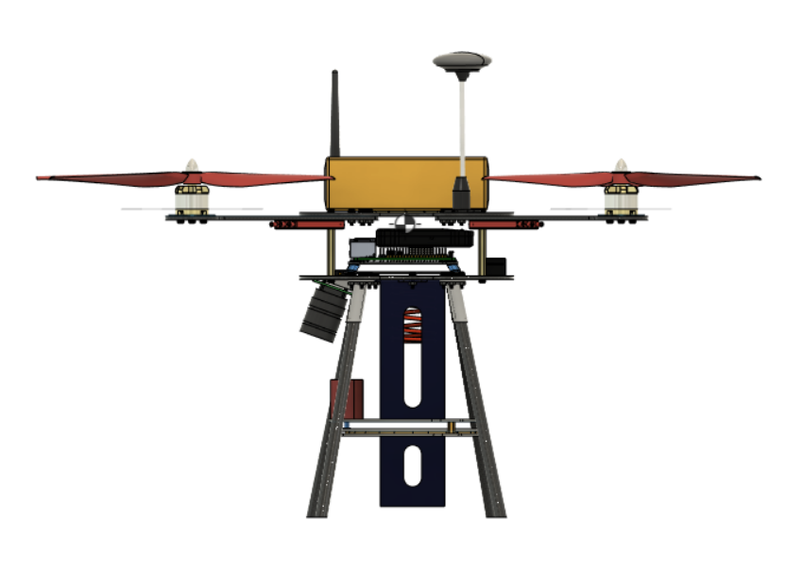

The CG is just above the Pixhawk board and approximately at the centre of XY plane.

**3.Final specs and bill of materials:**

|  |  |  |  |
| --- | --- | --- | --- |
| **Sr.no** | **PART NAME** | **SPECS/MATERIAL** | **QUANTITY** |
| 1 | Frame | Carbon fibre | 1 |
| 2 | Motor | DYS D2836-7 1120KV | 4 |
| 3 | Battery | 6200MAH, 40C LI-PO BATTERY | 1 |
| 4 | GPS | Pixhawk 4 Neo M8N GPS | 1 |
| 5 | Flight controller | Pixhawk V2.4.8 | 1 |
| 6 | ESC | ReadytoSky 40A 2-4S ESC | 4 |
| 7 | Propeller CW | Carbon Nylon 1045 | 2 |
| 8 | Propeller CCW | Carbon Nylon 1045 | 2 |
| 9 | Payload Dropping Mechanism | Acrylic | 1 |
| 10 | microcontroller | Raspberry Pi 4 | 1 |
| 11 | Camera | Raspberry Pi High Quality Camera | 1 |
| 12 | Telemetry Kit | Boscam 32Ch Wireless AV Transmitter TS832 Receiver RC832 | 1 |
| 13 | Landing gear | Carbon fibre | 4 |
| 14 | Buzzer | Pixhawk kit | 1 |
| 15 | Receiver | FS-R6B FlySky 2.4Ghz 6CH Receiver | 1 |
| 16 | M3 x 8mm screws and nut |  | -- |
| 17 | PPM encoder | Pixhawk kit | 1 |

**4.Methodology for Autonomous operations:**

**Autonomous Operation using raspberry Pi –**

1. **Mission setup** –

Setup the path for drone by using Mission Planner software. Mission Planner allows to define waypoints and create a mission that includes the desired path for the drone to follow. Set the waypoints and altitude to navigate the drone over the desired ground path.

1. **Installation of Raspbian OS -**

* Installed latest Raspbian OS on rPi using Raspberry Pi imager and SD card; while installing OS we specify the ssid and password of the network over which we are going to connect the rPi to remotely ssh into it.
* Used Putty Client to remotely ssh into raspberry pi
* Firstly, we connect the rPi and the computer to same network whose ssid and password we specified earlier, then we find IP address of rPi over that network using Angry IP Scanner software
* Now we ssh into rPi using Putty Client by providing that IP address. By doing this we can code rPi over a Wi-Fi network

1. **Connection between Pixhawk and Raspberry Pi** – Established connection using UART serial communication protocol.

Steps for establishing UART communication –

* + - Connect the Pixhawk’s telemetry port (Telem2) to the Raspberry Pi’s GPIO pins. The UART pins used for communication are typically GPIO 14 (TX) and GPIO 15 (RX).

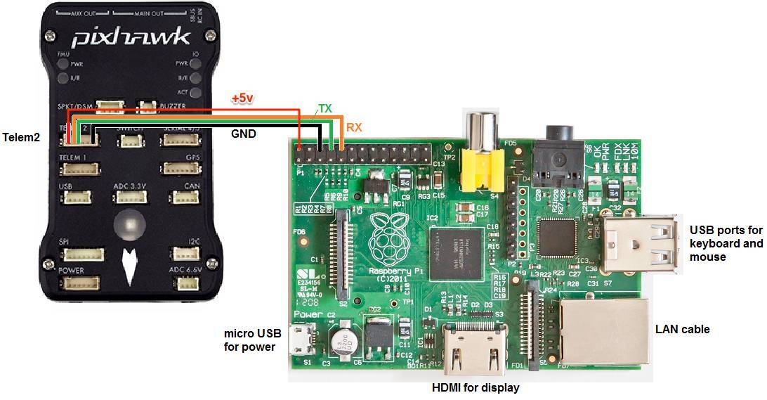

* + - By default, the Bluetooth module on rPi uses UART so first disable it by making changes in config.txt file: -

sudo nano /boot/config.txt

dtoverlay = disable-bt

pseudo reboot

**Installation of necessary libraries on rPi**

* + - sudo pip install pyserial

**pySerial** is a Python library that provides a simple and convenient way to establish and manage serial communication connections.

* + - sudo pip install dronekit

**dronekit** offers a simplified and Pythonic interface for sending commands, receiving telemetry data, and managing mission planning.

* + - sudo pip install mavproxy

**MAVProxy** serves as a versatile ground control station that facilitates communication between the Pixhawk and external systems, provides monitoring capabilities, and enables command execution.

1. **Detection of the hotspot –**

First, we set up camera using sudo raspi-config command and then making cghanges inside interfacing options.

1. **pseudo code for python script -**

import time.

import cv2 # OpenCV library for image processing.

from dronekit import connect, VehicleMode, LocationGlobalRelative

# Connect to the Pixhawk autopilot

vehicle = connect ('/dev/ttyAMA0', baud=57600, wait_ready=True

target_altitude = h

vehicle.simple_takeoff(target_altitude)

# Wait until the vehicle reaches the desired altitude

# Function to handle image detection and payload drop

def detect_and_drop():

# Capture and process images for object detection

camera = cv2.VideoCapture(0) # Using the appropriate camera device

while True:

_, image = camera.read()

# Process images using previously developed object detection model

# If the object is detected:

if object_detected:

print ("Object detected")

# Change vehicle control to Raspberry Pi

vehicle.mode = VehicleMode("MANUAL")

# Descend to an altitude of h2 meters

target_altitude = h2

# Wait until the vehicle reaches the desired altitude

# Drop the payload

drop_payload()

# Change vehicle control back to the mission planner

vehicle.mode = VehicleMode("GUIDED")

# Close the camera

camera.release()

# Function to handle mission planner commands

def handle_mission_planner_commands():

# Continuously listen for mission planner commands

while True:

# Process mission planner commands

# ...

# If a specific condition is met (e.g., a command to start object detection):

if start_detection_condition:

# Transfer control to Raspberry Pi for image detection and payload drop

detect_and_drop()

# Resume mission planner control after payload drop

# Executing the mission planner command handling function in a separate thread

import threading.

mp_thread = threading.Thread(target=handle_mission_planner_commands)

mp_thread.start()

1. **Payload drop logic** – Developed a programe on the Raspberry Pi that monitors the ML model's output for target detection. When the target is detected, command will be sent from the Raspberry Pi to the Pixhawk to trigger the payload release mechanism.This is done by sending a specific MAVLink command or using custom signals connected between the Raspberry Pi and the Pixhawk.
2. **Resuming the control** - The Raspberry Pi sends a command to the Pixhawk flight controller to initiate the payload drop at the designated altitude. After payload drop, the Raspberry Pi sends another command to the Pixhawk to indicate the completion of the drop and instruct it to resume listening to commands from Mission Planner through the first communication channel.

**Autonomous execution of script -**

Developed the system in such a way that the script starts executing with a specific time delay after the power is connected. So we don’t need to be connected to the network for execution of script. We monitor the voltage levels on the GPIO pins to detect the power connection.

**5.Summary of innovations in design:**

Our drone design includes various novel elements that improve its performance and

utility. To begin,

* we added a Glass Fibre Reinforced Polymer (GFRP) layer covering to the landing gear to considerably boost its strength and endurance. We made by adding Hardener in Polyester matrix and adding Cobalt as a fast-reacting catalyst. Then we added a layer of glass-fibre for completing the coating. This has layer a density of only 1.3 gm/cc but improves the strenght of abs many fold. We first make an additive manufactures intricate part with abs then add the layer of gfrp on top of it improve its strength many fold.

This coating gives the drone enhanced structural integrity, allowing it to endure severe impact and pressures during landing missions.

* We have created a bio-inspired payload mechanism inspired by the human eye and also the shutter of a camera. This mechanism is very intricate but easy to manufacture with acrylic laser cutting techniques. The mechanism is very light, fast, and very efficient in terms of timely dropping of payload.
* We made the payload human centered where we made slots matching the width of average human finger so, as to ensure easy loading of payload.
* We made it Spring loaded which provides extra velocity to payload while dropping which lets it overcome the air resistance coming from the drone and reduces its deflection.
* We also added an extra run to payload and made it in the shape of the vertical box with less clearance which ensure the straight dropping of the payload without any deflections.

In summary, our drone design combines a GFRP coating for increased landing gear

robustness, a one-of-a-kind payload dropping mechanism inspired by the camera

shutter mechanism, and a carbon fibre frame to produce a lightweight yet durable

construction. These advancements substantially improve the drone's performance,

durability, and operating capabilities, establishing it as a cutting-edge and dependable

option for a wide range of applications.

**APPENDIX**

**Other Orthographic Views of Parts:**



